PRUEBA SABER 11

PARTE 3

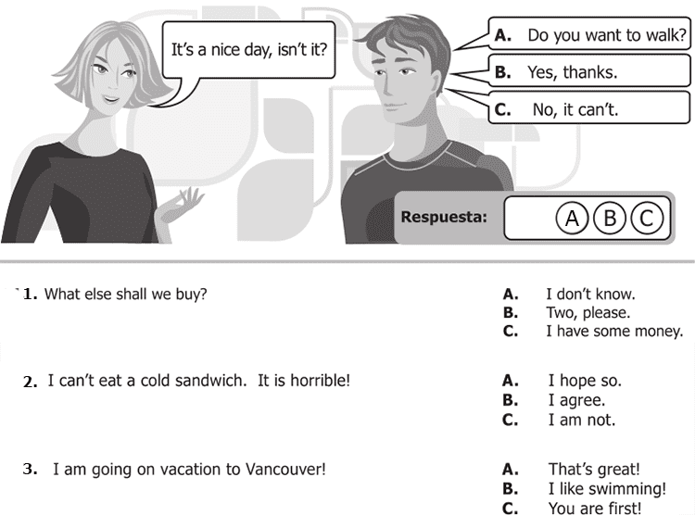

**4 .** It rained a lot last night! A. Did you accept?

**X**. Did you understand?

C. Did you sleep?

5. Grandma, shall I hold those bags for you? A. I'm not afraid!

B. What's the matter?

**X**. That's fine.

6. How much is that umbrella? A. Anything else?

**X**. 50 dollars.

C. Cash only!

7. Can I use your printer? **X**. Just a minute

B. Do it this way

C. Think about it

8. Who´s the girl? **X**. She´s my sister

B. Yes, she is

C. That´s ok

9. Do you know Peter? A. Which?

**X**. who?

C. What?

10. Can you pass me the salt?  **X**. Here you are

B. I like it

C. It´s all right

**Continue next page**

